**ASSIGNMENT 1**

**TEAM ID:** PNT2022TMID04545

**PROJECT NAME: Plasma Donor**

**Name:**Dharanidharan k

1. **Create registration page in html with username, email and phone number and by using POST method display it in next html page.**

**Register.html**

<html>

<head>

<style>

*{

padding: 0;

box-sizing:content-box;

}

body{

background-image: linear-gradient(to right,rgb(229, 158, 128), white);

background-size:cover;

}

.login{

text-align: center;

width: 25%;

height: 30%;

padding: 25px;

margin-left: auto;

margin-top: 10%;

color: black;

font-size: large;

}

</style>

</head>

<body>

<div class=login>

<form action="http://localhost:5000/login" method="POST">

<fieldset>

<legend> Details</legend>

Enter Email ID:

<p><input type="email" name="mail" placeholder="Enter your mail" required/></p>

Enter Username:

<p><input type="text" name="nm" placeholder="Enter your username" required/></p>

Enter Phone Number:

<p><input type="tel" name="phone"/ placeholder="Enter your phone number" required></p>

<p><input type="submit" value="submit"/></p>

</fieldset>

</form>

</div>

</body>

</html>

**Form.html**

<html>

<head>

<style>

body{

background-image: linear-gradient(to right,rgb(242,139,98), white);

background-size:cover;

}

.details{

text-align:center;

margin-left: auto;

margin-right:auto;

margin-top: 10%;

}

p{

font-size: 25px;

}

</style>

</head>

<body>

<div class=details>

<h1> Thank you for submitting the form....</h1>

<h3> Check the details that you have entered...</h3>

<br>

<p> EMAIL ID : {{email}} <br>

USER NAME : {{name}} <br>

PHONE NUMBER : {{phone}} </p>

</div>

</body>

</html>

**App.py**

from flask import Flask,redirect,url_for,render_template,request

app=Flask(__name__)

@app.route('/login',methods=["POST","GET"])

def login():

if request.method=="POST":

mail=request.form["mail"]

user=request.form["nm"]

phone=request.form["phone"]

title="Thank you!"

return render_template("form.html",email=mail,name=user,phone=phone)

if __name__=='__main__':

app.run(debug=True)

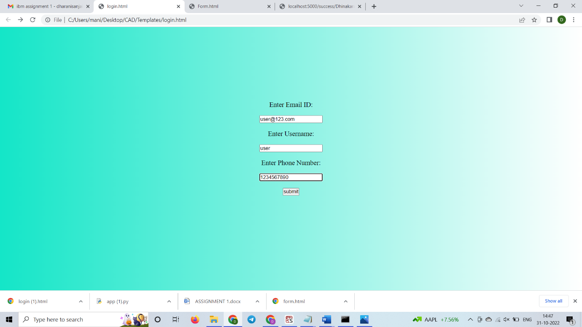

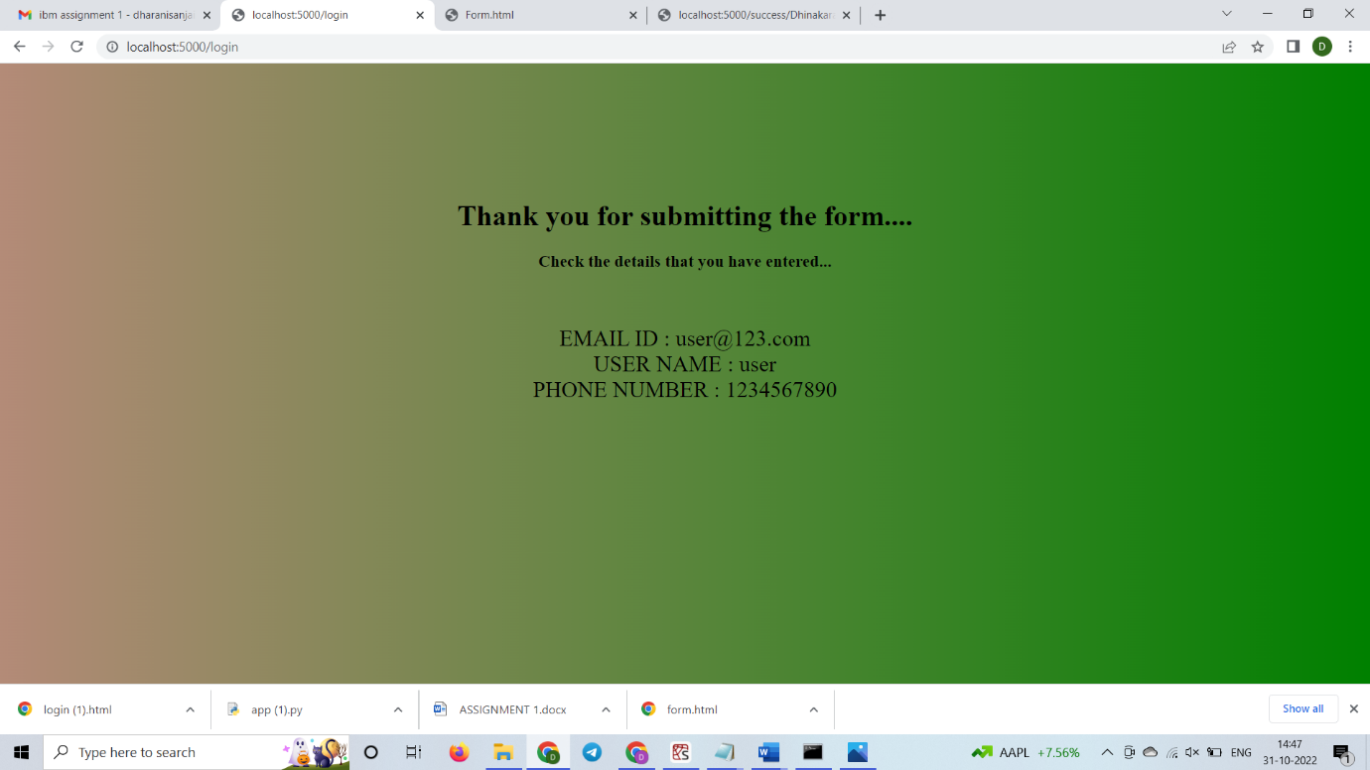

1. **Develop a flask program which should contain at least 5 packages used from pypi.org.**

**Index.html**

<!DOCTYPE html>

<html lang="en">

<head>

<meta charset="UTF-8">

</head>

<body>

<form action="http://localhost:5000/login" method="post">

<p> Enter the name</p>

<p><input type="text" name="input_name"></p>

<p><input type="submit" name="submit"></p>

</form>

</body>

</html>

**App.py**

from flask import Flask,redirect,url_for,render_template,request

app=Flask(__name__)

@app.route('/')

def index():

return render_template("index.html")

@app.route('/success/<name>')

def success(name):

return "welcome %s"%name

@app.route('/login',methods=["POST","GET"])

def login():

if request.method=="POST":

user=request.form["nm"]

return redirect(url_for("success", name = user))

else:

user=request.args.get("input_name")

return redirect(url_for("success",name=user))

if __name__=='__main__':

app.run()

